- Variety of Student Work

Rhythmic Color
Grade: 1st, 2nd, 3rd (Clearwater Elementary)
Medium: Watercolor and Acrylic Paint
Objective: Students will be able to…
- see and discuss the work of Alma Woodley Thomson.
- use the art principle, Rhythm, by creating a Radial/Line design.

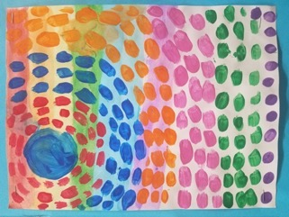
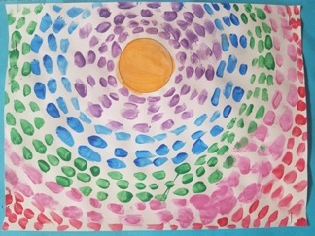
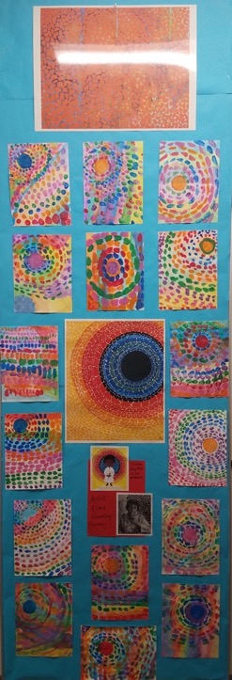
Layers to an Ecosystem
Grades: 4th & 5th Grade (Artistically Talented, CW)
Medium: cardboard, acrylic paint, oil pastel
Objective: Students will be able to…
- effectively utilize cardboard in an artistic form
- understand ecosystems and reproduce an environment
- color and mix oil pastels
- understand of layering with foreground, middle ground, and background.
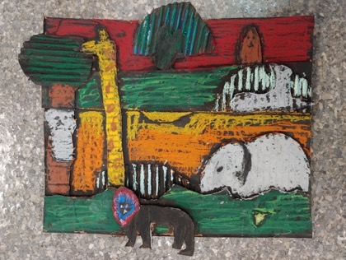
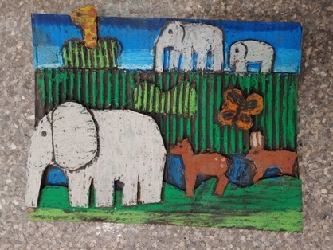
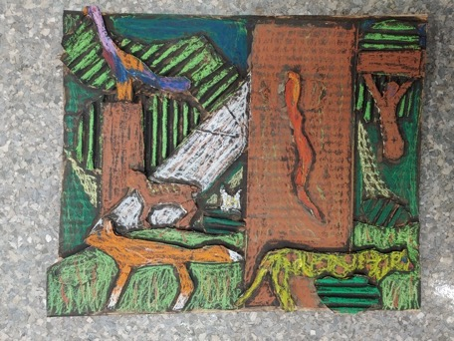

Multicultural Expressive Portraits
Grade: 1st, 2nd, 3rd (Clearwater Elementary)
Medium: Watercolor and Acrylic Paint
Objective: Students will be able to…
- Create an expressive self-portrait using a mirror.
- Development a background using expressive lines and colors
- Notice the differences we, as humans, all have
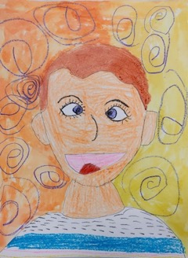
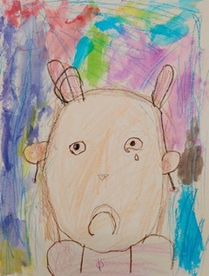
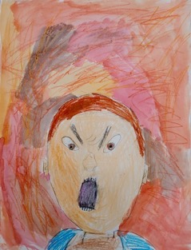

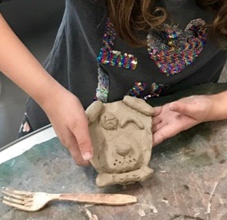
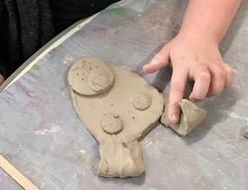
Dream Pets
Grade: 3rd (Clearwater Elementary)
Medium: Ceramics/Clay
Objective: Students will be able to…
- know how to construct a clay form such as forming coils, slabs and slipping/scoring
- Demonstrate knowledge of basic shapes to form either a cat or dog.
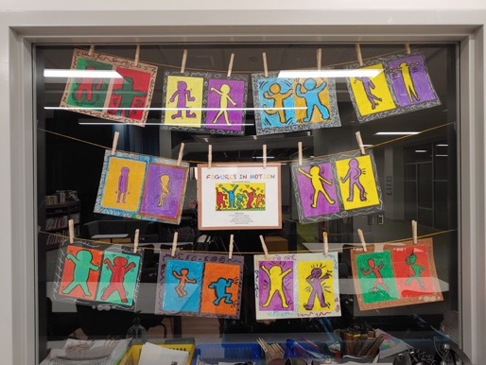
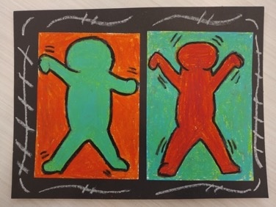
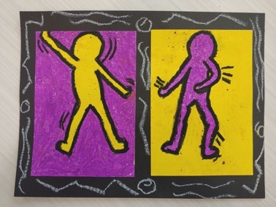
Figures in Motion
Grade: 5th & 3rd (Clearwater Elementary)
Medium: oil pastel
Objective: Students will be able to…
- Draw a figure from a live model
- Identify and create contrast using complementary colors
- Create a sense of motion

Cloud Creatures
Grade: 1st, 2nd (Clearwater Elementary)
Medium: Sharpie and colored pencil
Objective: Students will be able to…
- Use their imagination to create art
- Use line, shape, patterns, and texture to add details to their cloud creature.
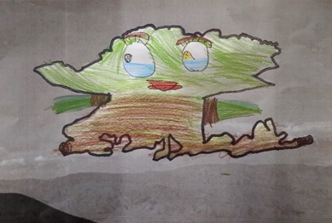
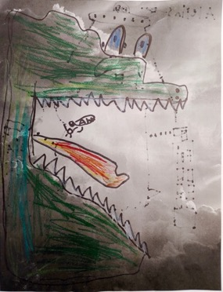
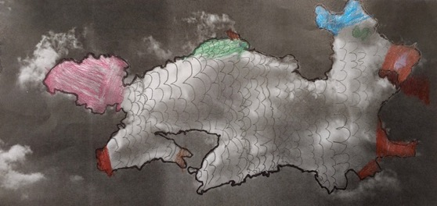
Animal Scratch Board
Class: Intro Art (North Central High School)
Medium: x-acto knife and black scratch board
Objective: Students will be able to…
- transfer printed image onto another paper using Graphite transfer method
- use an x-acto knife in a correct and safe manner
- create a white on black drawing.
- understand and create implied texture
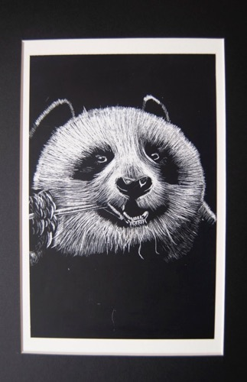
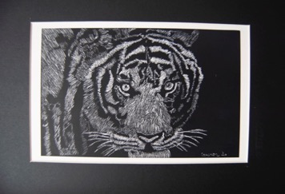
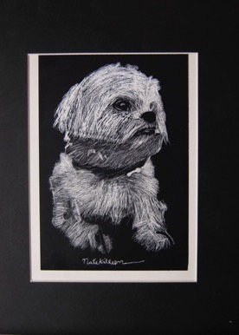
Still-Life Observational Drawing
Class: Advanced Drawing (North Central High School)
Medium: white charcoal on black paper
Objective: Students will be able to…
- create an observational drawing using a still life arrangement
- apply to value to create form
- use shading techniques such as hatching
- show surface texture of objects, implied texture
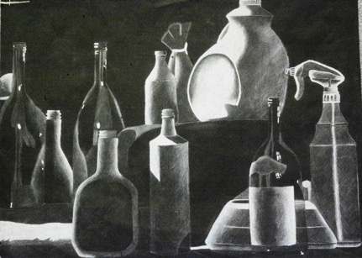
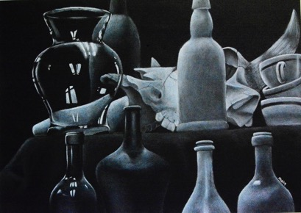
Pattern & Identity
Class: Intro Art (North Central High School)
Medium: colored pencil
Objective: Students will be able to…
- create a grid portrait of a celebrity and communicate their identity through pattern
- use various colored pencil techniques such as hatching, cross hatching, blending, and scumbling.
- Learn and understand how to effectively use pattern design when creating a portrait.

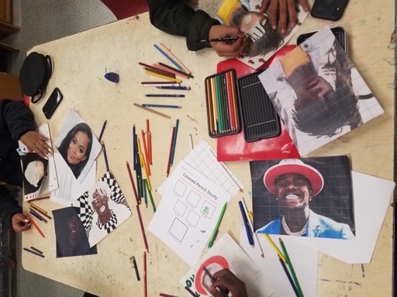
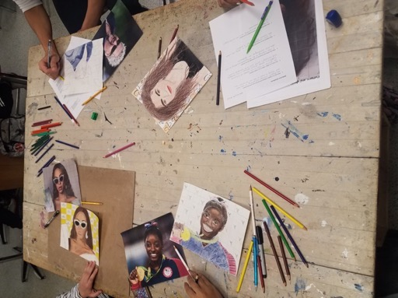

My Da Vinci Notes
Class: Advanced & Beginning Drawing (North Central High School- Online Learning)
Medium: pencil
Objective: Students will be able to…
- create sketches inspired Da Vinci
- find objects that communicate their identity
- construct a composition using image and text

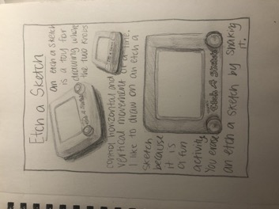
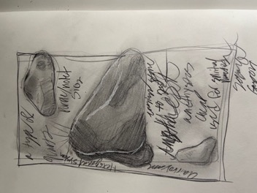

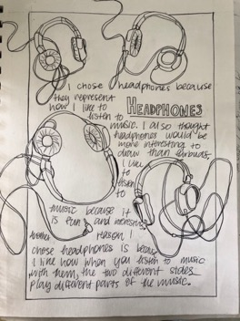
What the kids Say
Class: Advanced & Beginning Drawing (North Central High School- Online Learning)
Medium: pencil
Objective: Students will be able to…
- reflect on their own language spoken within their own culture
- draw a 2-point perspective word
- expand and express their creativity with font and background
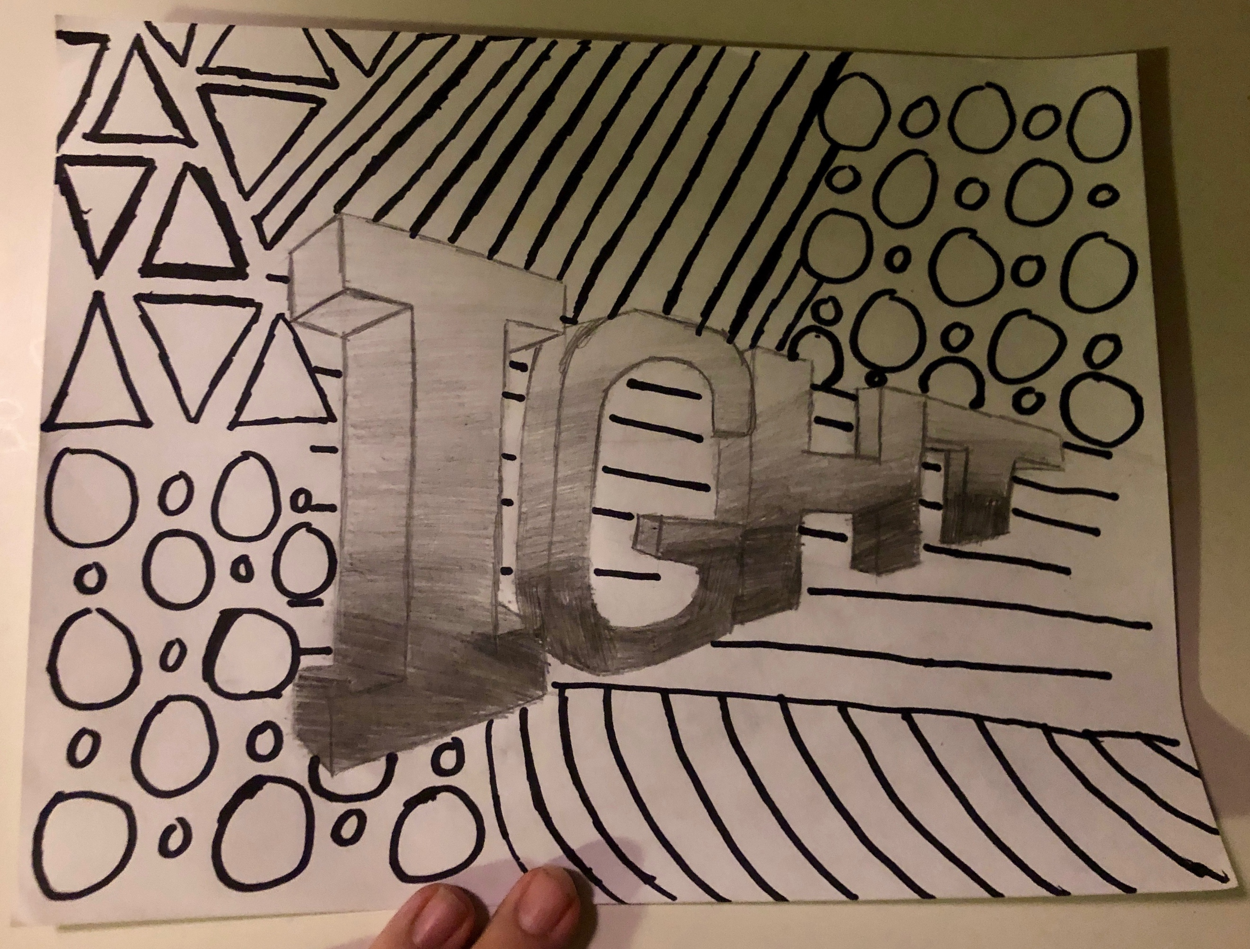
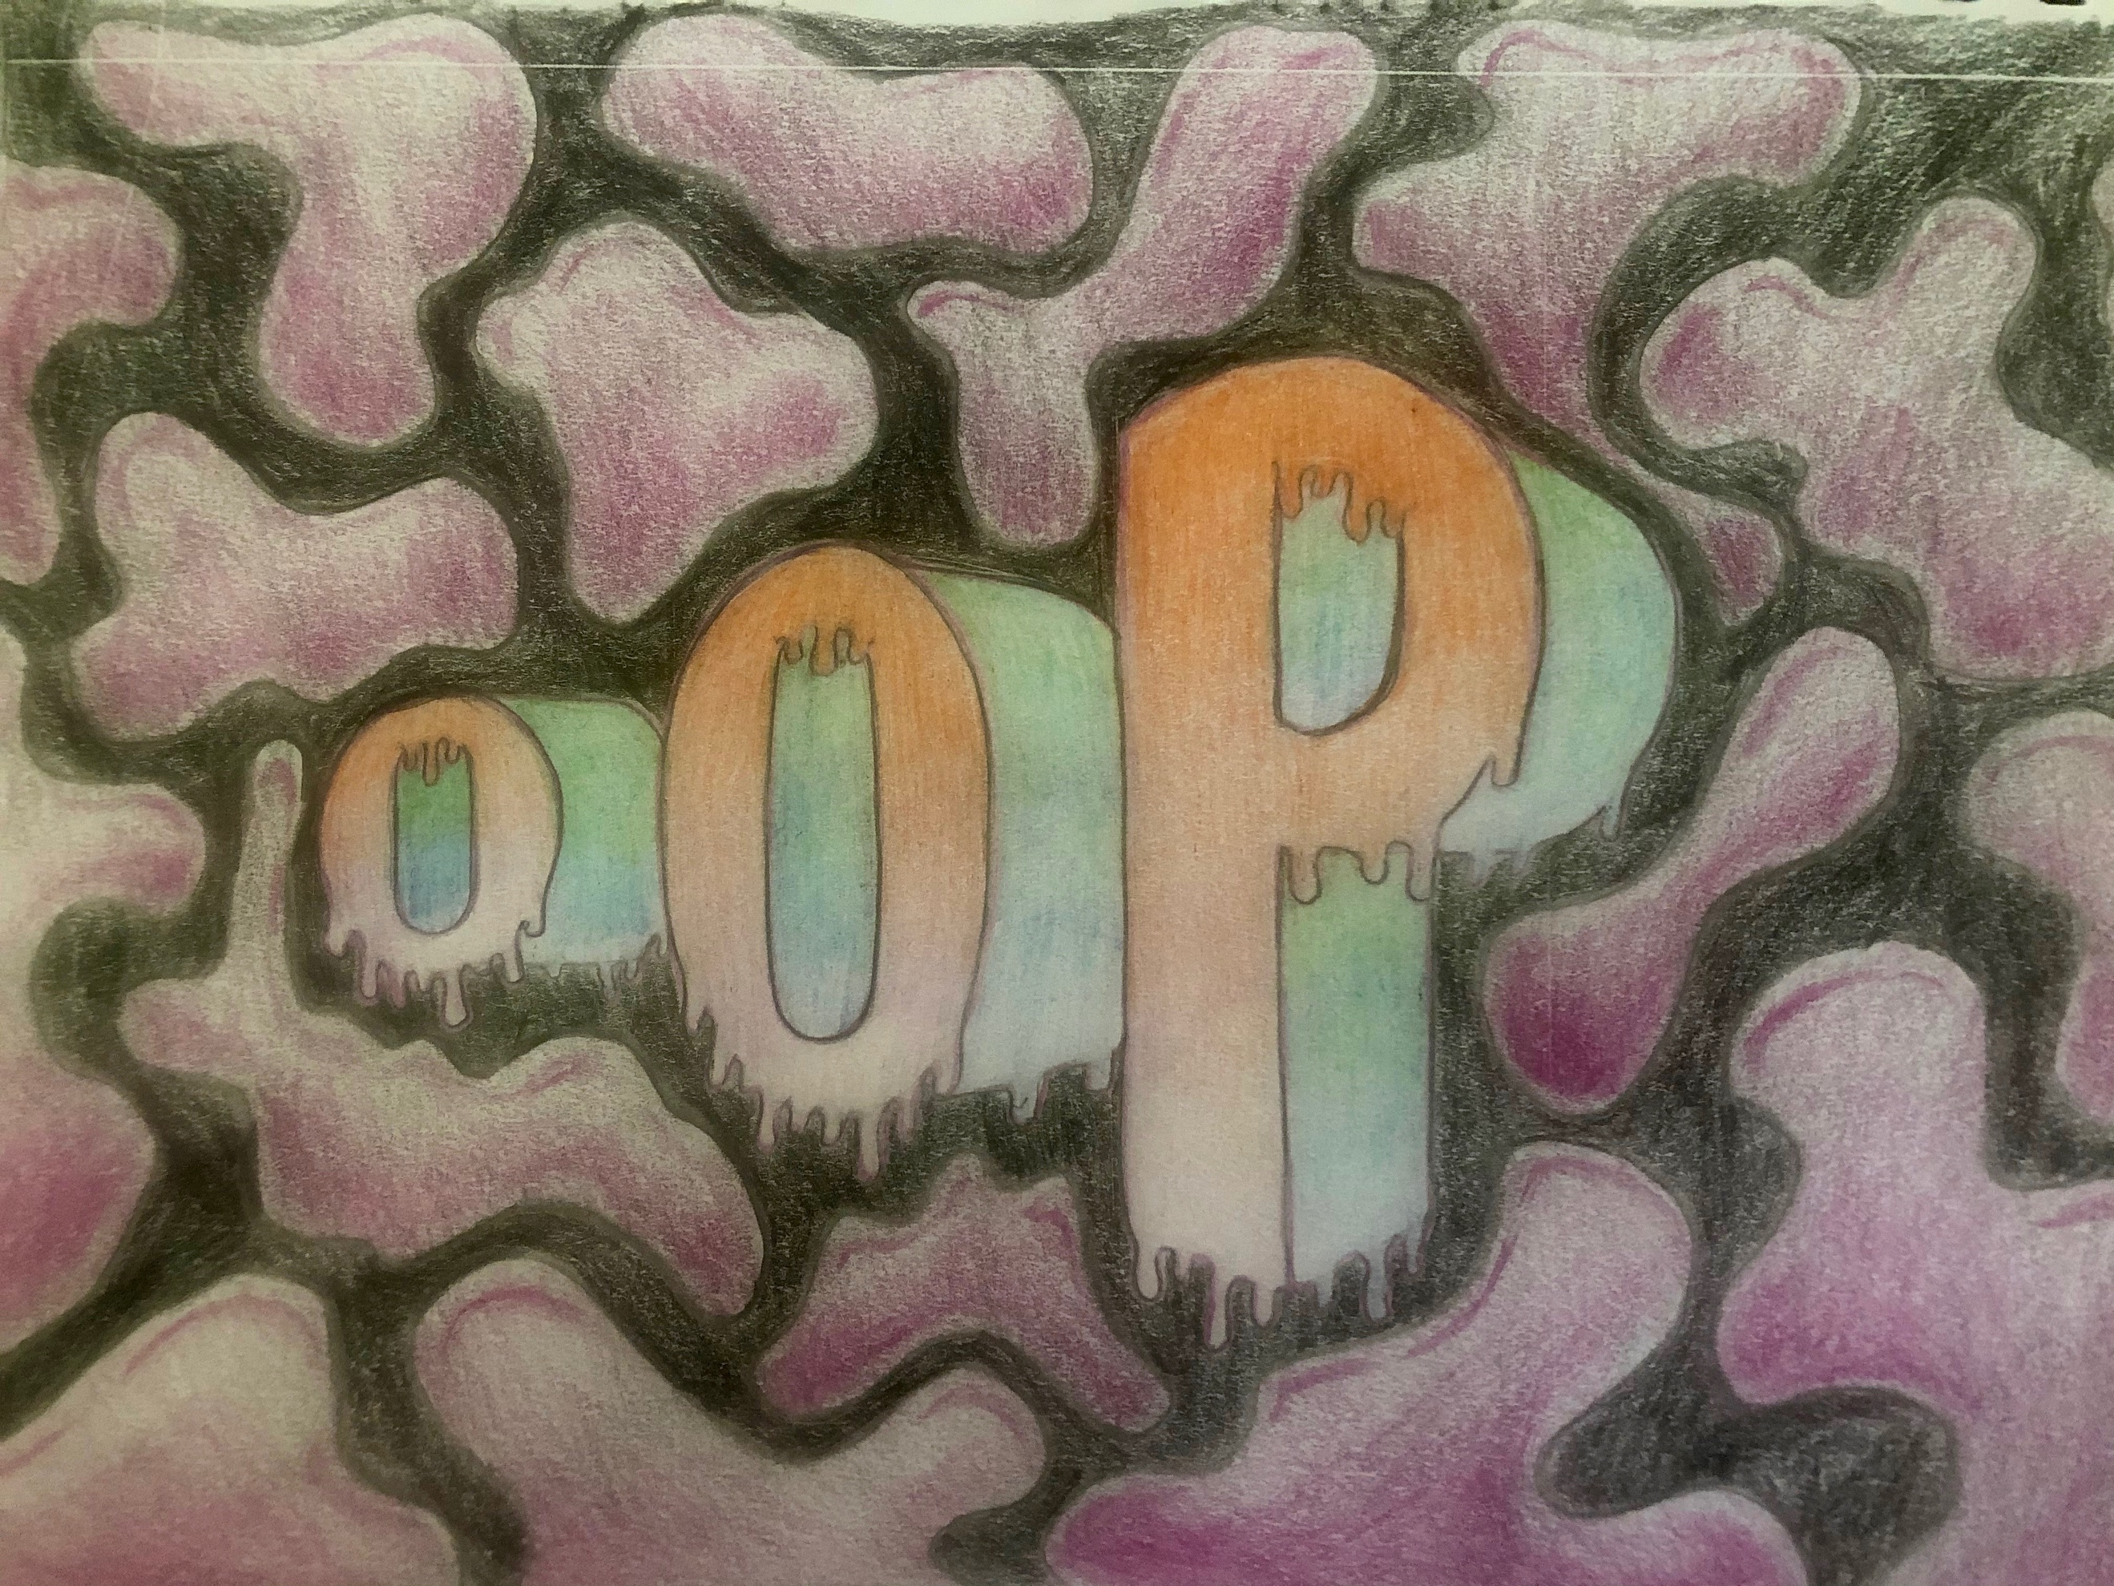
Joys and Fears in Life
Class: Advanced & Beginning Drawing (North Central High School- Online Learning)
Medium: pencil
Objective: Students will be able to…
- create a narrative inspired by two different artists, Nathan Pyle and Fran Krause.
- Design their own characters with dialogue attached.
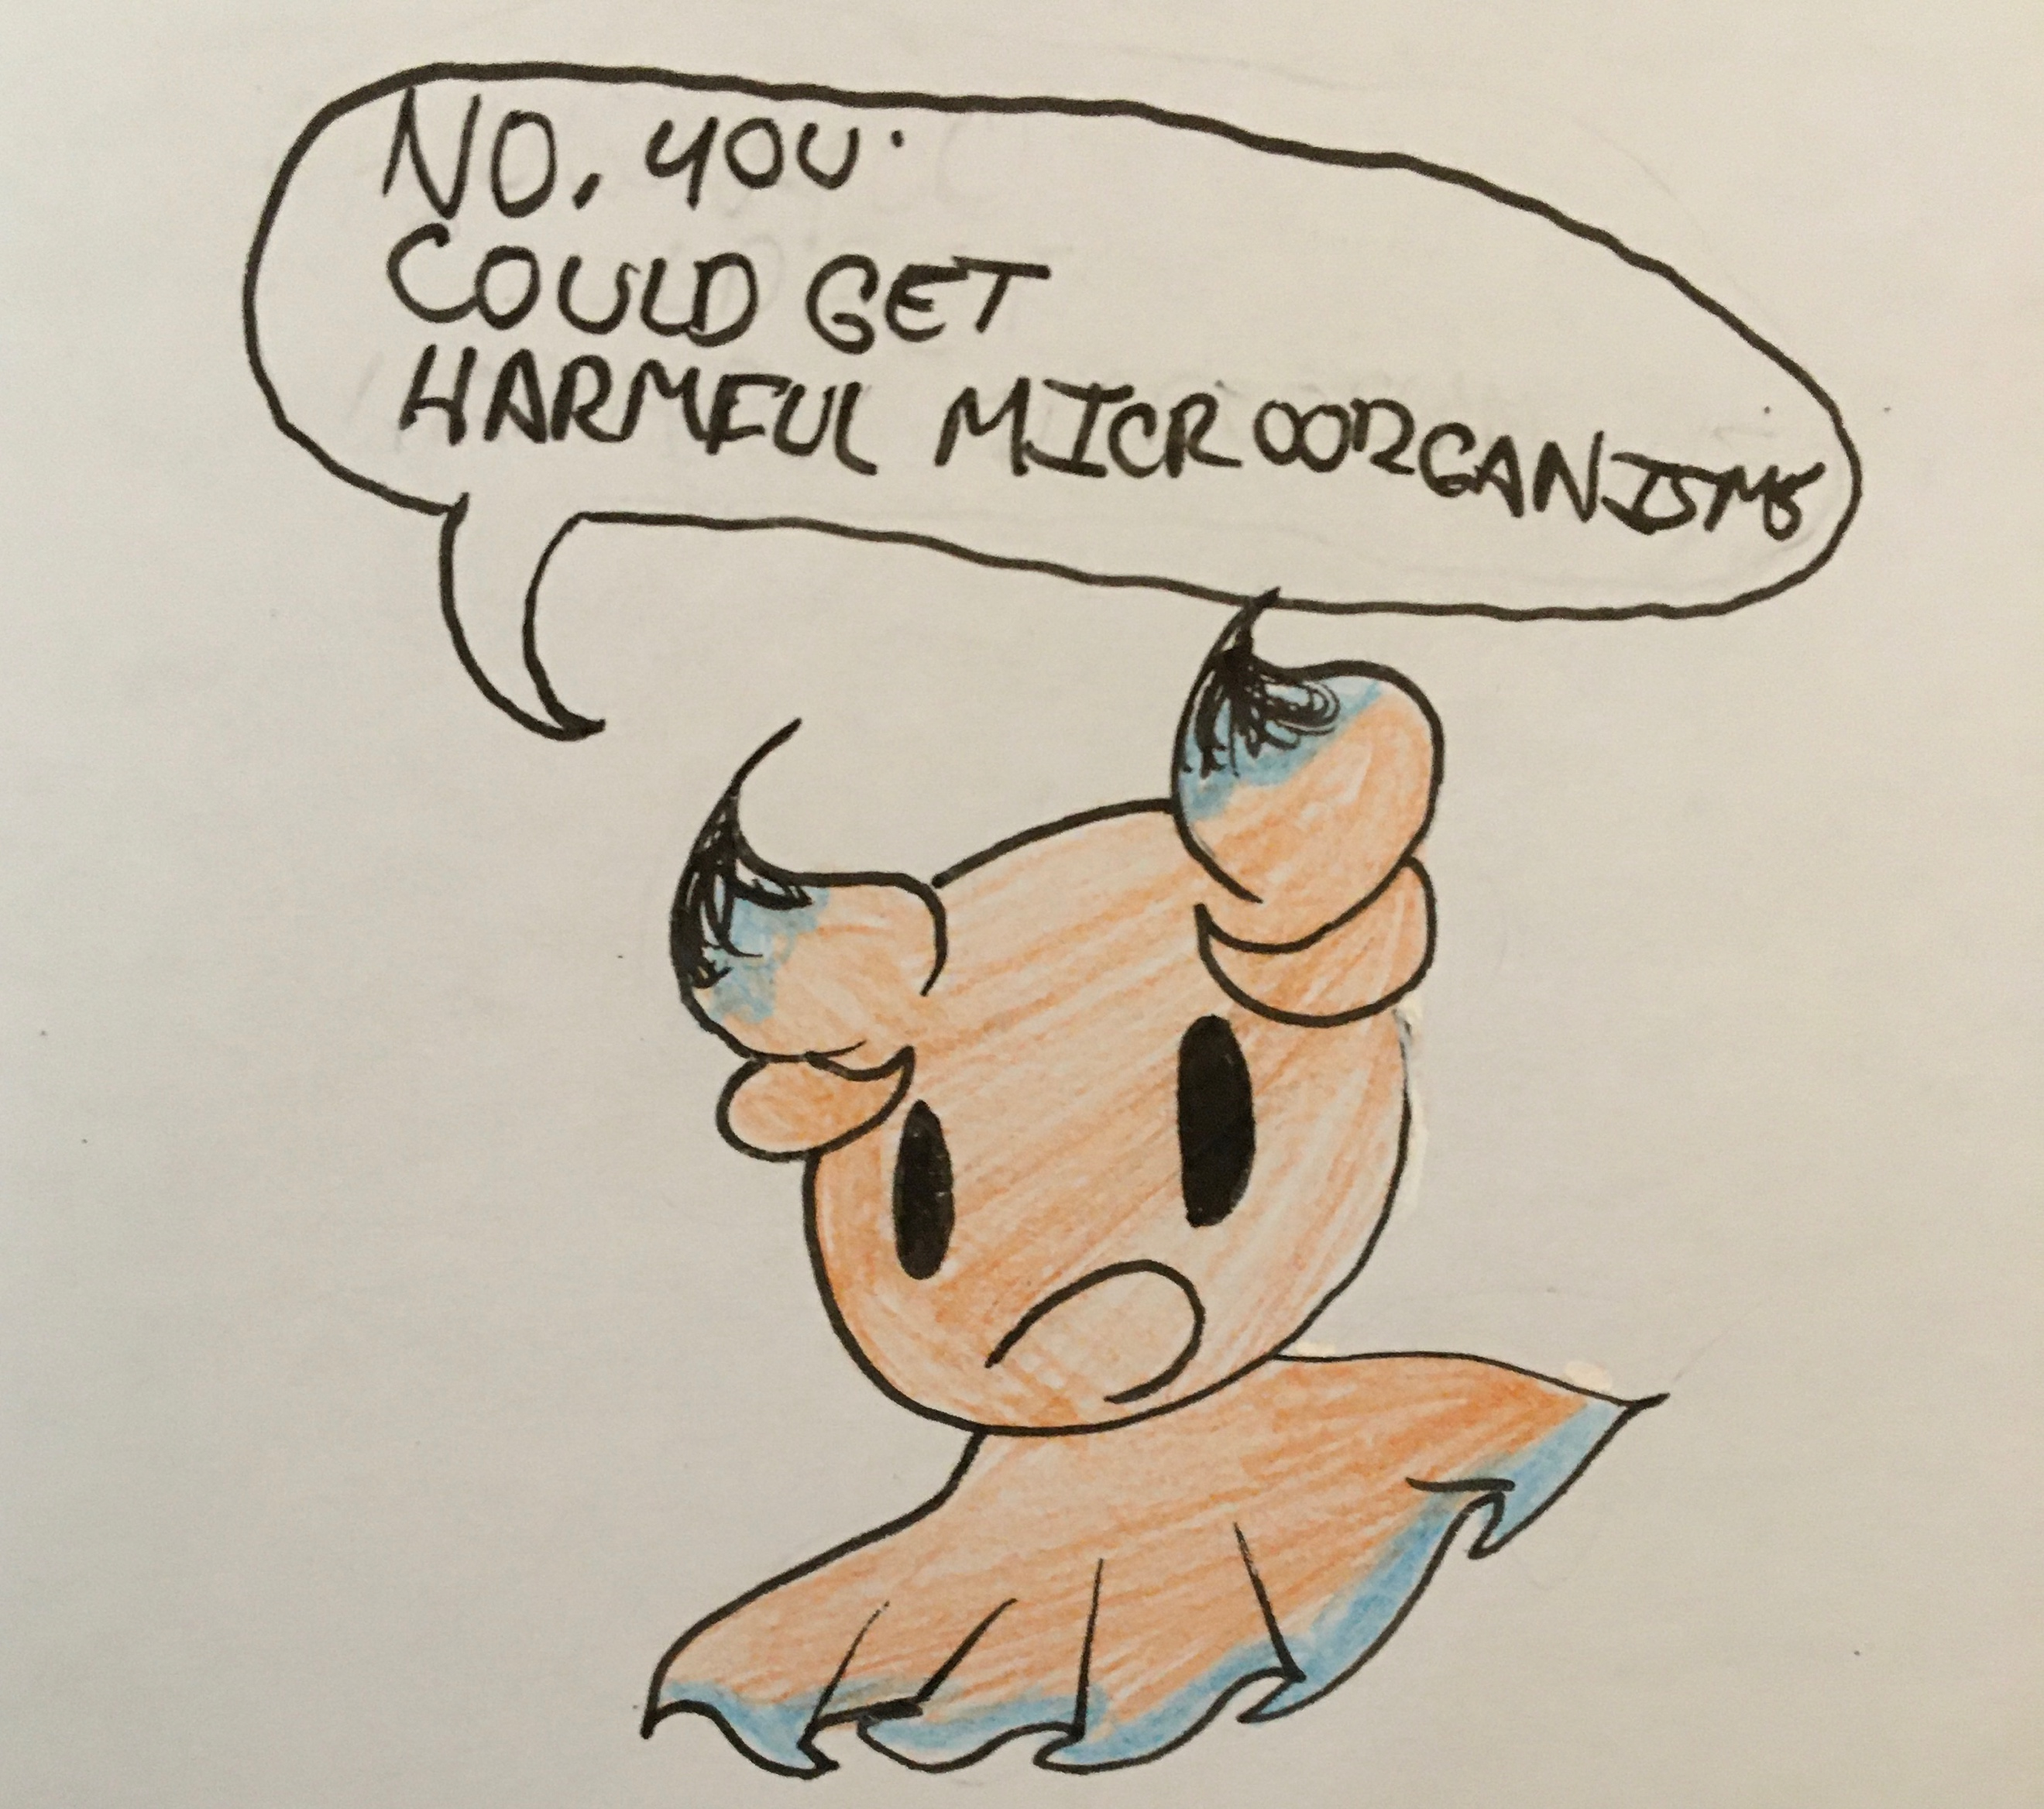
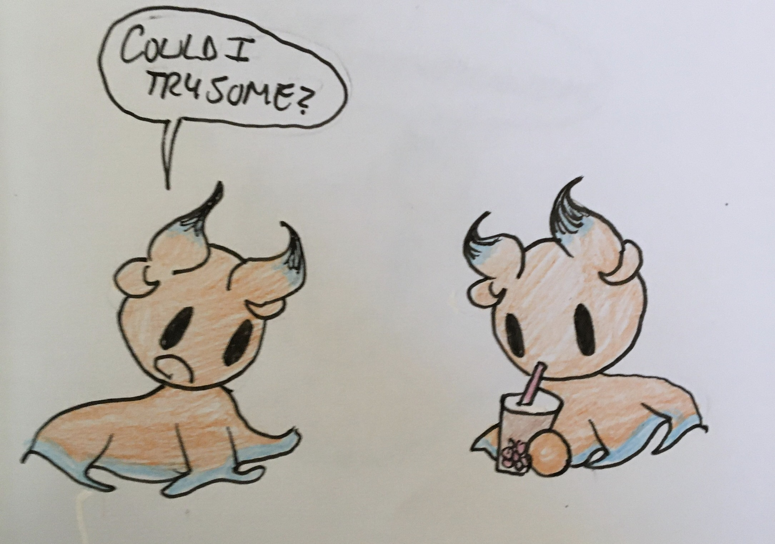
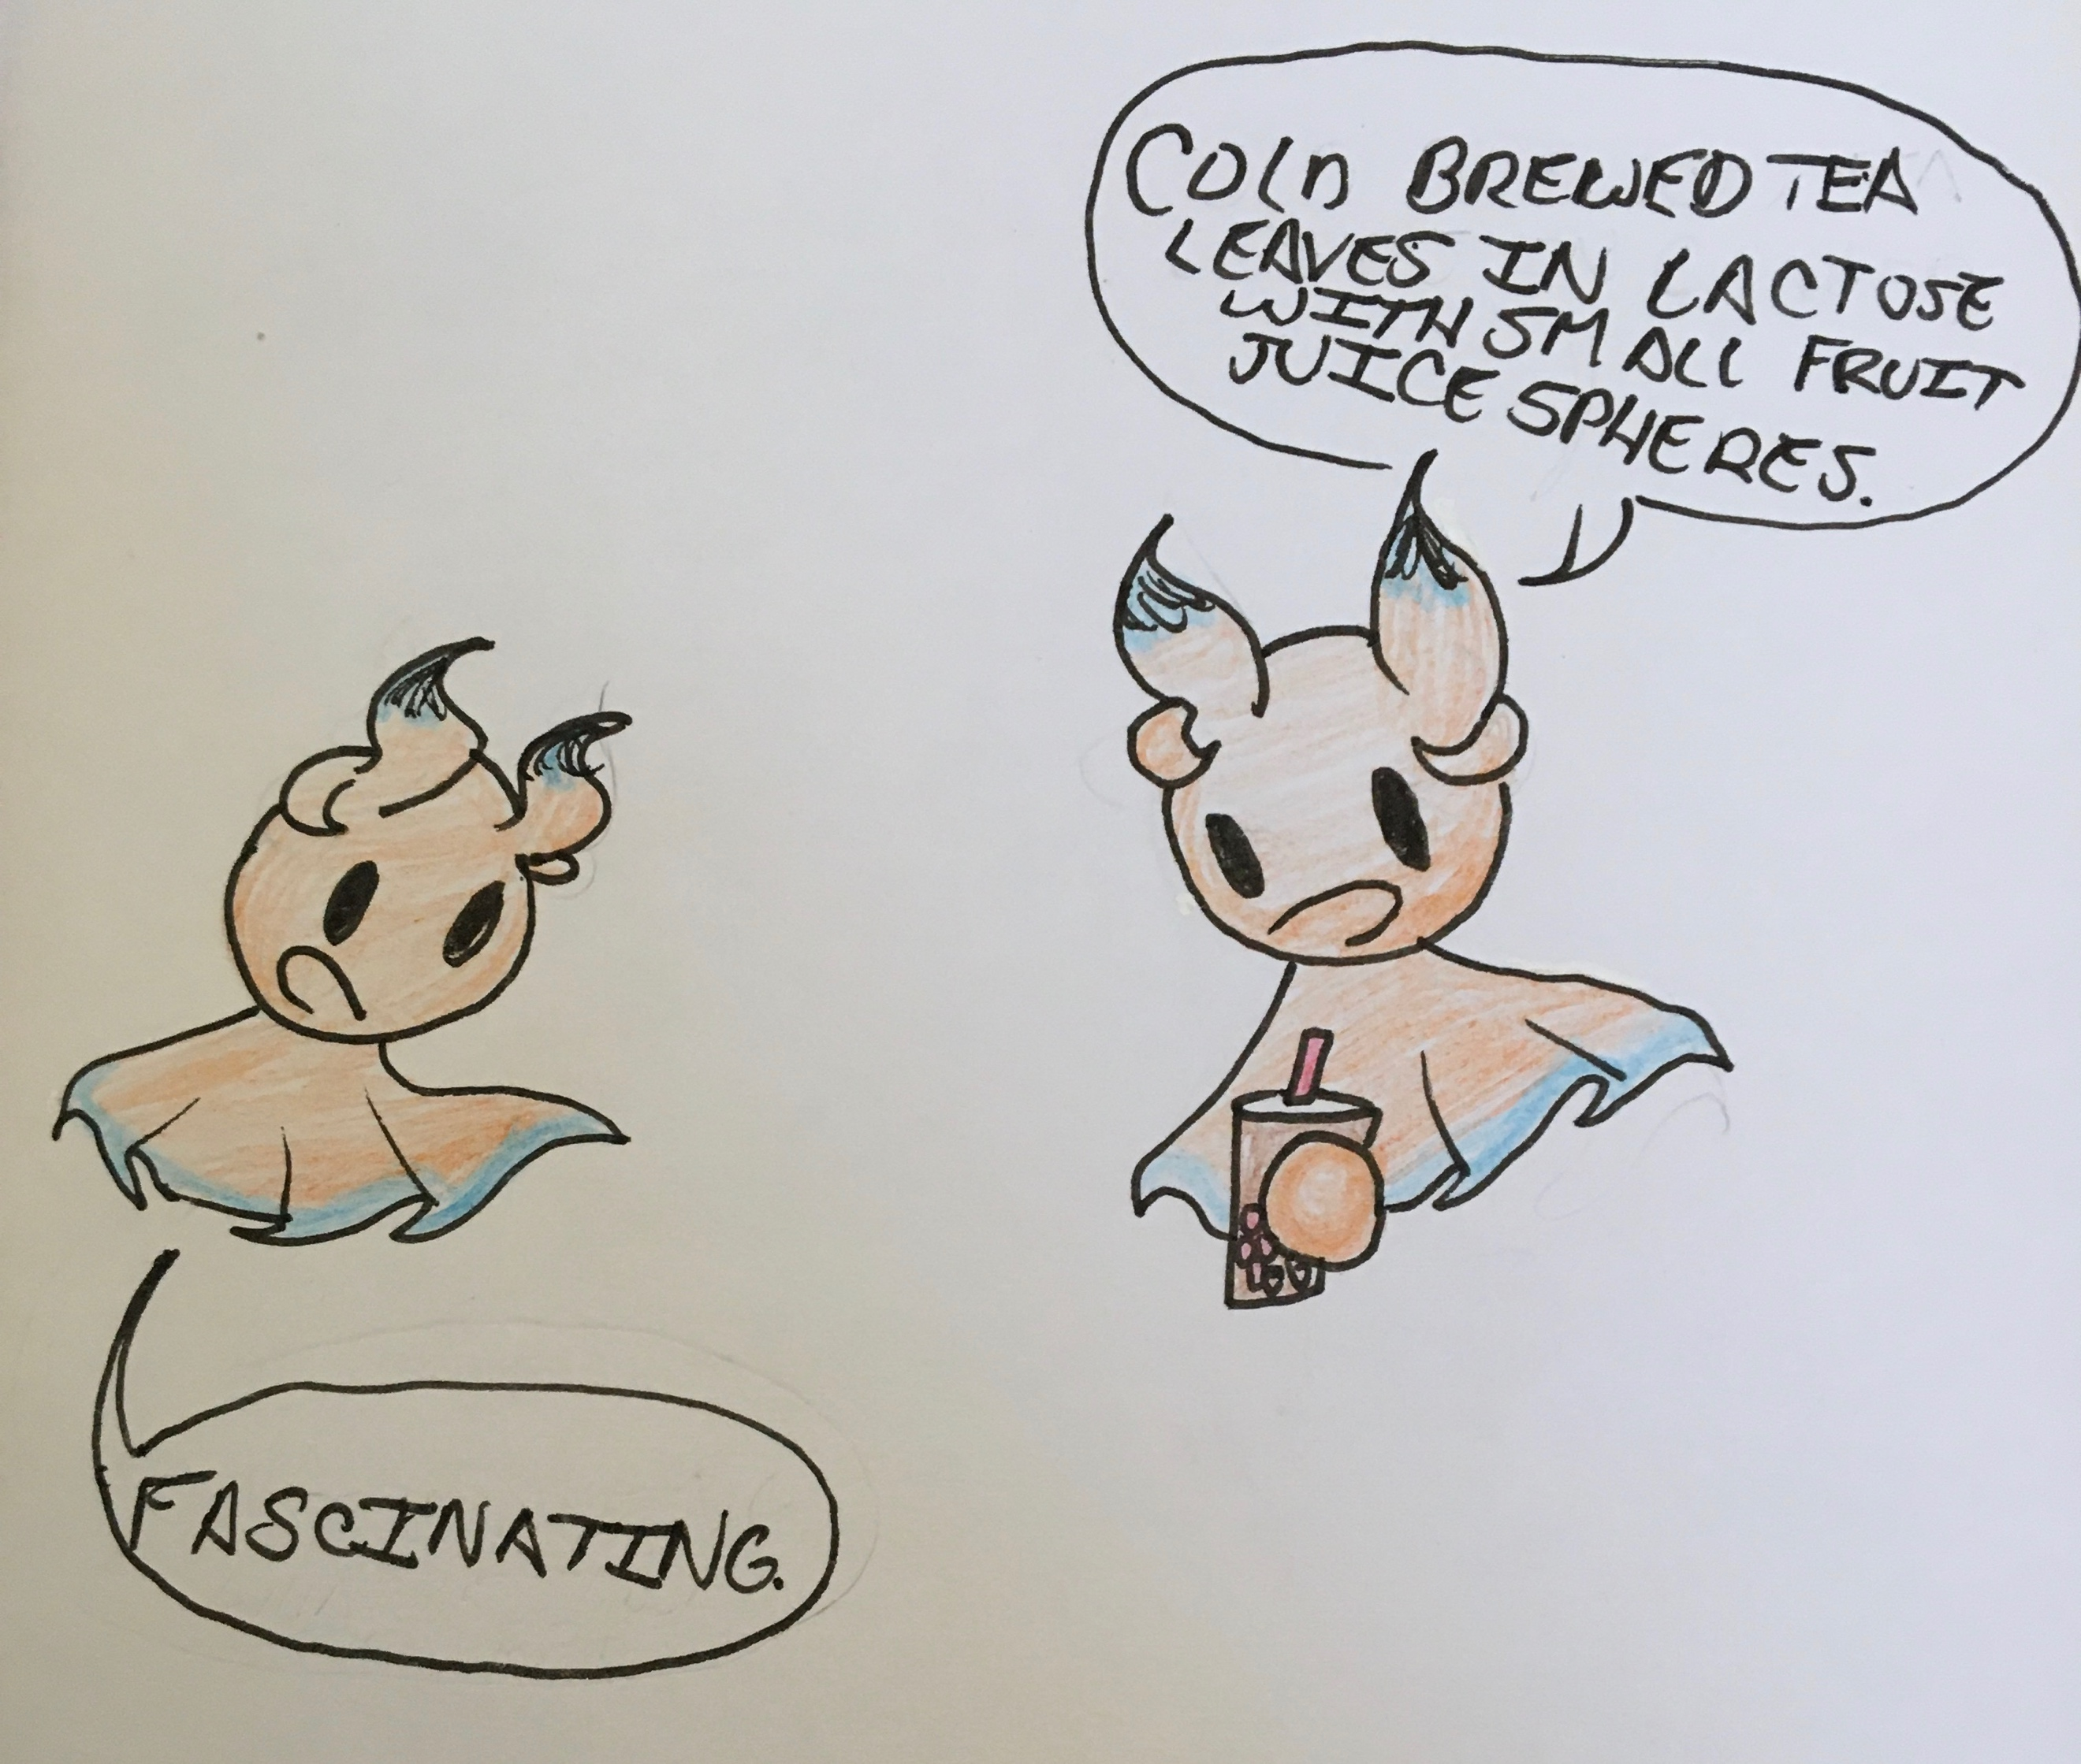
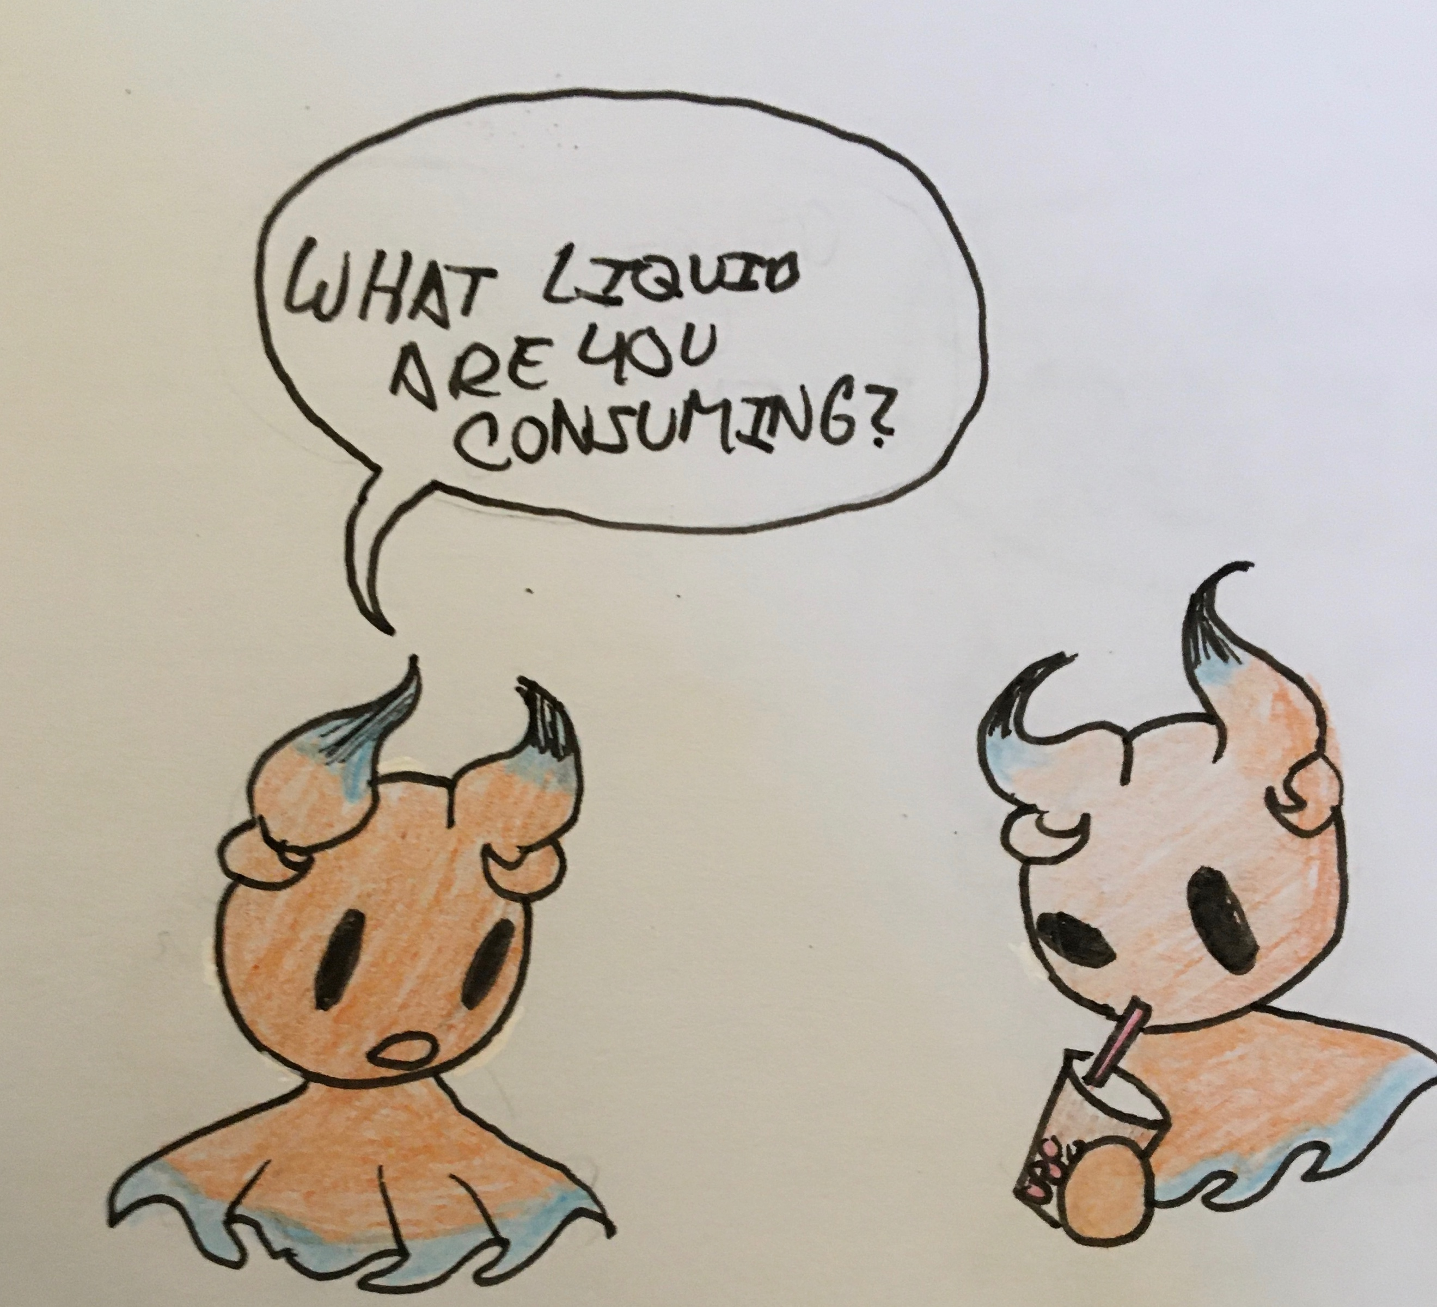
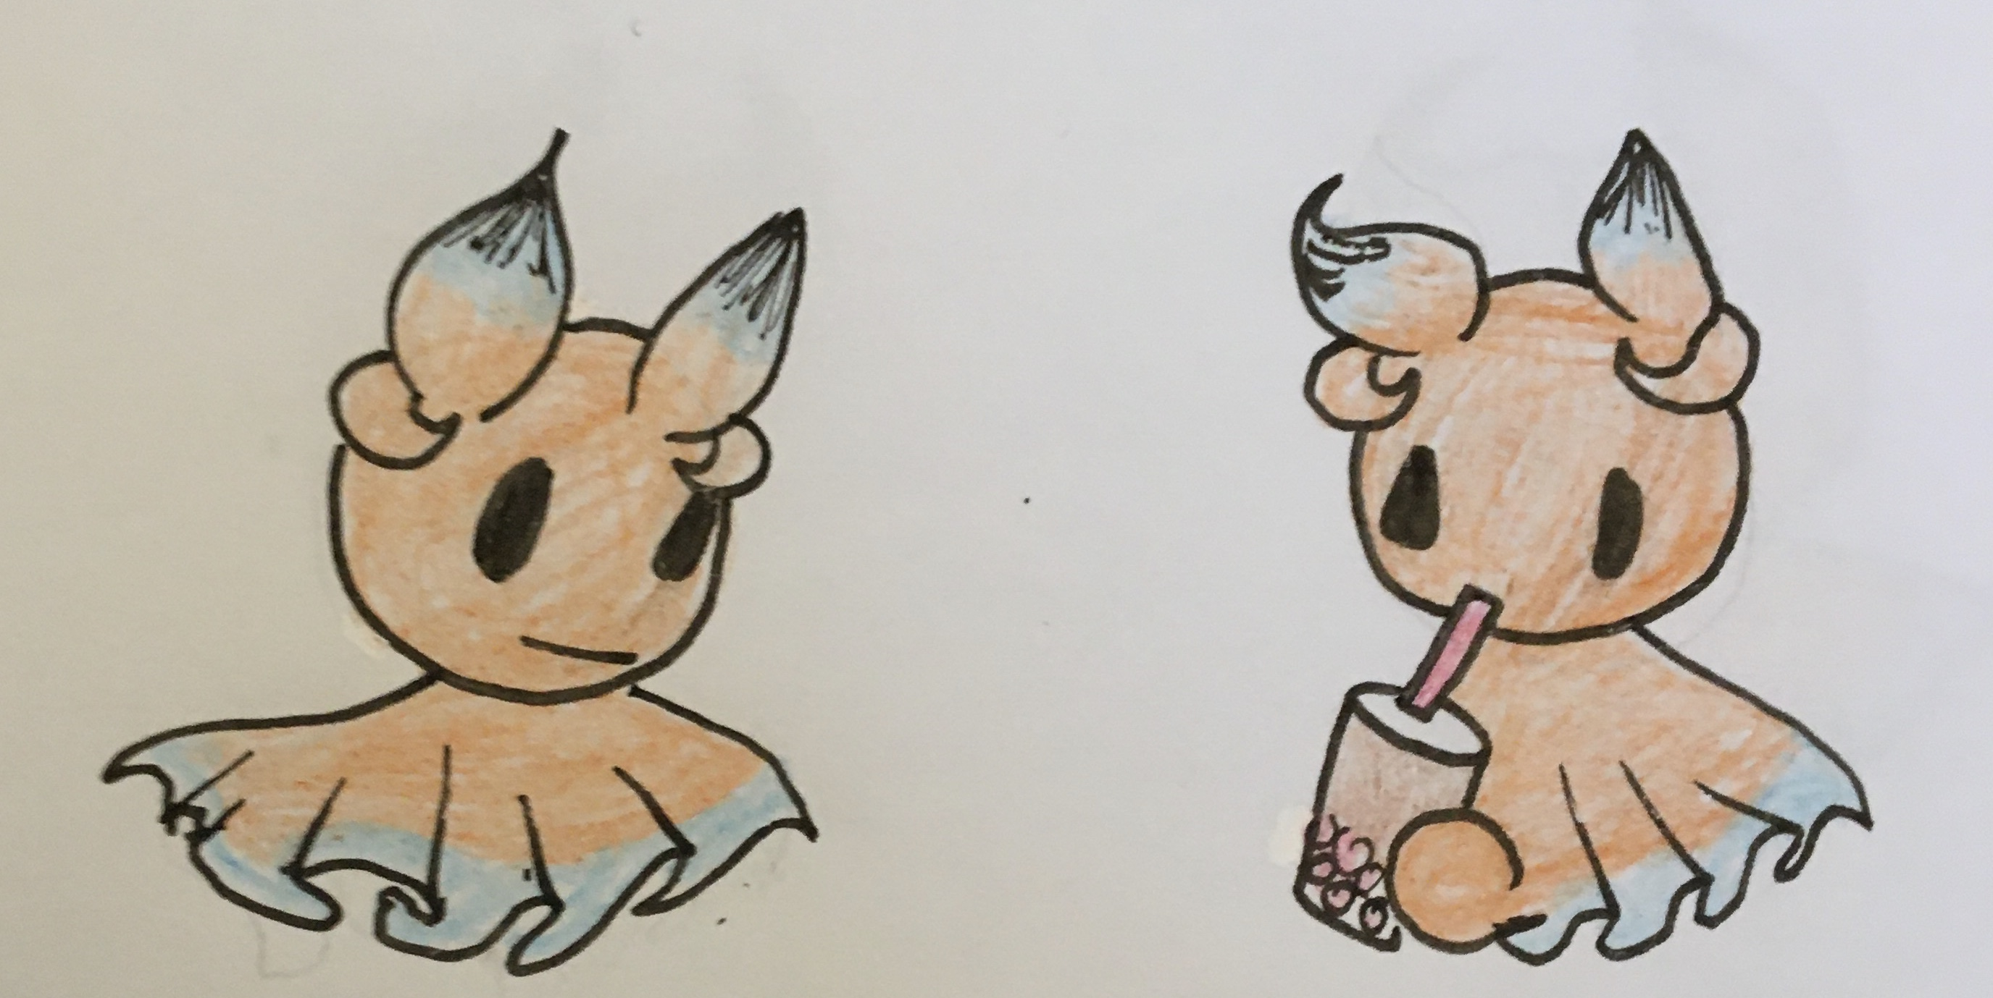
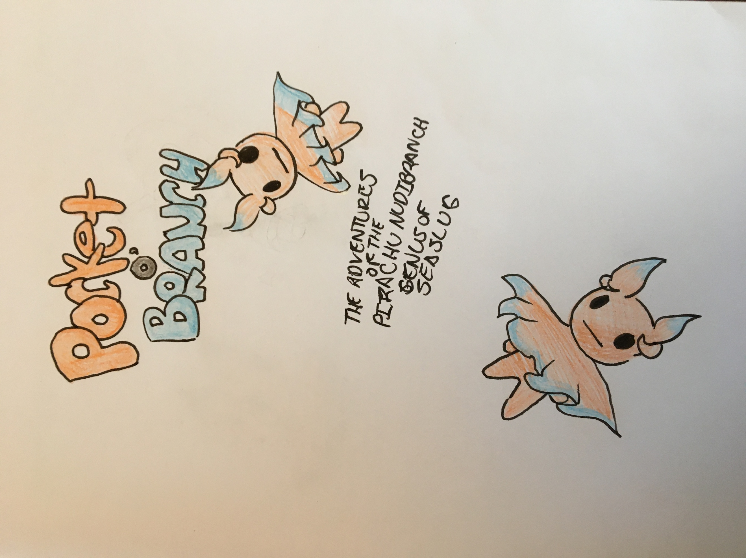
- Create a book to implement their panels.

